[Active Directory Lab]

[Installation using VMWARE AND ISO]

Cyril Thomas – v1

2025

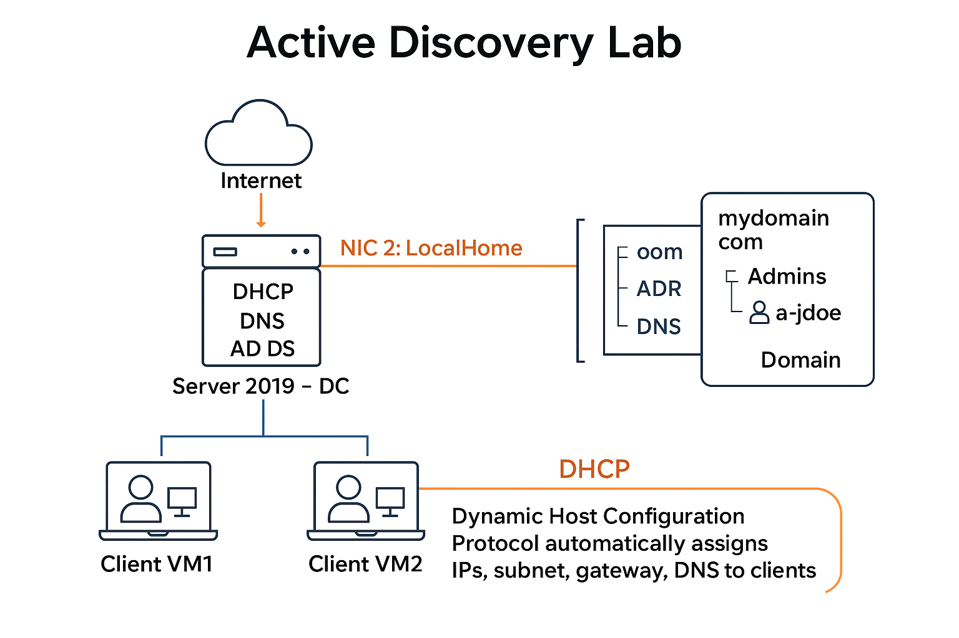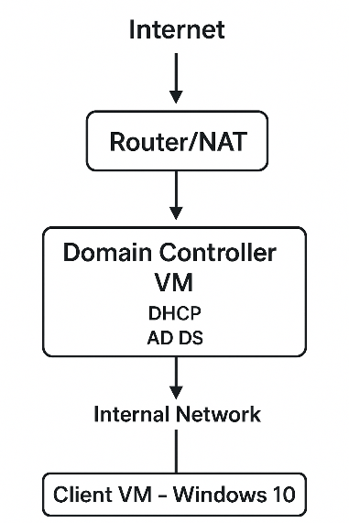

| **Role / Service** | **Purpose** | **Notes** |
| --- | --- | --- |
| **AD DS** | Authenticates users, stores AD database, applies Group Policies | Promotes server to domain controller |
| **DNS** | Resolves domain names for internal clients | Usually installed with AD DS |
| **DHCP** | Automatically assigns IPs, subnet, gateway, DNS to clients | Bind to NIC 1 (InternalNetwork) |
| **RAS / NAT** | Provides routing/NAT or VPN access | Optional, configure via Routing and Remote Access Wizard |

**1. Download Required ISOs**

* **Windows 10 ISO** – for client virtual machines.
* **Windows Server 2019 ISO** – for the domain controller and server roles.

**2. Windows Server 2019 – Network Configuration**

1. Click the **Network icon** in the system tray (near the time and calendar).
2. **Identify dual NICs** (one for internal network, one for internet).
3. **Rename NICs for clarity**:
   * NIC connected to the internet → LocalHome
   * NIC connected to the internal network → InternalNetwork
4. Assign a **static IP address** to the internal NIC for server-to-client communication.

**3. Create a Domain**

1. Open **Server Manager Dashboard** → select **Add Roles and Features**.
2. Choose **Active Directory Domain Services (AD DS)** → click **Install**.
3. After installation, **restart the server** if prompted.
4. In Server Manager, click the **notification flag** → select **Post-Deployment Configuration**.
5. Choose **Add a new forest**.
6. Provide a **domain name**, e.g., mydomain.com.
7. Complete the wizard and **install AD DS**.

**4. Add a Dedicated Domain Administrator**

1. Open **Active Directory Users and Computers**.
2. Navigate to the **newly created domain**.
3. Create an **Organizational Unit (OU)** → name it Admins.
4. Create a **new user** with a consistent naming convention (e.g., a-jdoe).
5. Right-click the new user → select **Properties** → assign the user to the **Domain Admins** group.

**5. Configure Remote Access (RAS/NAT)**

1. Open **Server Manager Dashboard** → **Add Roles and Features**.
2. Select **Remote Access** → click **Install**.
3. Open **Routing and Remote Access** from Tools.
4. Run the **Routing and Remote Access Wizard** → select **Configure and Enable**.
5. Follow prompts to configure NAT or VPN as needed for lab network routing.

**6. DHCP – Dynamic Host Configuration Protocol**

**Purpose:** Automatically assigns network configuration to clients:

* IP address
* Subnet mask
* Default gateway
* DNS server

**Dual-NIC Server Context:** Ensures clients can access AD, printers, internal resources, and the internet while being managed centrally.

**Server 2019 – Domain Controller Role**

As a Domain Controller (DC), the server:

1. Authenticates all domain users and computers.
2. Stores Active Directory data for users, computers, and groups.
3. Applies policies via Group Policy.
4. Provides DNS so clients can locate domain resources.
5. Optionally provides DHCP (assigning IPs and network settings).
6. Manages traffic between networks if multiple NICs are used.

**7. Setting Up DHCP on the Server**

1. Open **Server Manager** → **Add Roles and Features** → select **DHCP Server** → click **Install**.
2. After installation, open **DHCP Management** from Tools.
3. Notice that **IPv4 and IPv6** may show errors initially.
4. Right-click **IPv4** → **New Scope**.
5. Configure:
   * **Address range** for client IPs.
   * **Lease duration** (default = 8 days; can be shortened for dynamic networks).
   * **DHCP options** such as the domain controller’s IP for DNS.
6. Activate the scope → click **Finish**.

**Lease Duration Note:**

* Lease duration is the **time a client can use an IP before renewing**.
* Short leases are useful for dynamic networks; long leases for stable networks.

**DHCP Workflow**

**[Client VM] ----DHCP Discover----> [Server NIC 1: InternalNetwork]**

**[Server DHCP] --Offer IP / Lease--> [Client VM]**

**[Client VM] --Request IP----------> [Server DHCP]**

**[Server DHCP] --Acknowledge------> [Client VM]**

**(Client now has IP, subnet mask, gateway, DNS)**

* Lease Duration example: 8 days (can be configured shorter or longer).
* Renewal starts at 50% of lease duration.
* Expiration forces client to request a new IP.

**8. Adding Users via PowerShell**

1. Prepare a **file listing users** with first and last names.
2. Use a **PowerShell script (.ps1)** to loop through the file and generate users in Active Directory.
3. **Important:**
   * Run PowerShell as **Administrator**.
   * You may need to **disable the Execution Policy** temporarily:
   * Set-Execution Policy Unrestricted
4. Validate that users were created in **Active Directory Users and Computers**.

**9. Configure Internet Access**

1. Open **Server Manager** → **Local Server**.
2. Under **IE Enhanced Security Configuration**, select **Disable**.
   * This prevents Internet Explorer from repeatedly prompting users to confirm website access.

**Optional Notes / Best Practices**

* Bind **DHCP and DNS** to the internal NIC only to avoid conflicts.
* Ensure the second NIC (if connected externally) is **not used for domain traffic** unless specifically routed.
* For lab purposes, always verify IP connectivity using ping between server and client machines.